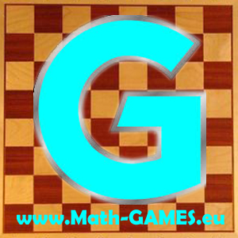
INVITATION
I invite you to the
Third Transnational Project Meeting
of the Erasmus+ project:
Math-GAMES - Games And Mathematics in Education for adultS Compendiums, Guidelines and Courses for Numeracy Learning Methods Based on Games
(2015-1-DE02-KA204-002260)

Each partner has to send his coordinator. More persons are welcome.

Programme

Date: Friday, 17th of June to Monday, 20th of June 2016

Place: Bucharest, Romania, Biblioteca Metropolitană “Mihail Sadoveanu” (Metropolitan Library "Mihail Sadoveanu"), Tache Ionescu Street, Nr 6, Sect. 1 http://www.bibmet.ro https://www.google.ro/maps/place/Biblioteca+Metropolitan%C4%83+Bucure%C8%99ti/@44.4440677,26.0972553,15z/data=!4m2!3m1!1s0x0:0x345b9f76bbebf207

Airport: International Airport Otopeni (Bucharest)

Website www.math-games.eu

Aims of the meeting
- evaluate the output O1 Compendium
- talk about the working process including the quarter reports and the administration
- discuss about the output O2 Guidebook

Timetable (subject to modification)

Fr 17.06.2016 Arrival Day

Prior to your arrival, please inform us about the duration of your stay, to book rooms in various hotels.

19:00: Get-together, whoever is already there, in a traditional restaurant

Sat 18.06.2016 First Working Day

09:30 Meeting at the Biblioteca Metropolitană “Mihail Sadoveanu” (Metropolitan Library "Mihail Sadoveanu")

10:00 Work time
- The coordinator will make a short presentation about the progress of the project.
- Each country will present their works.
- Discuss changes, corrections, improvements.
- Discuss the next output (O2) and the coming timetable

13:00 Lunch

13:30 Meeting goes on

17:00 Expected end

20:30 Dinner

Sun 19.06.2015 Second Working Day

Meeting at 09:30 in front of the hotel Ambasador

10:00 Work on project details at Muzeul Satului (Village Museum) Bucharest

13:00 Lunch

17:00 Short city tour: Casa Poporului, Muzeul de Istorie, Muzeul de Artă (People's House, Museum of History, Museum of Art) (individual, groups)

Mon 20.06.2015 Departure Day

Best regards,

Georgeta Adam

President of Ariadna Association

0040744376605

georgeta.adam4@gmail.com

